

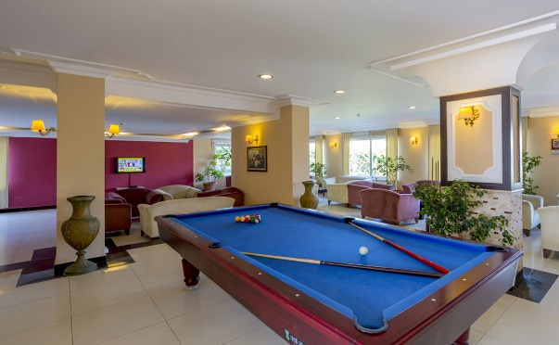HOTEL SERVICES

* **Main Restaurant**
* **Outdoor Swimming Pool**
* **Kinder Swimming Pool**
* **Slide Pool**
* **Lobby Bar**
* **Services Bar**
* **Pool Bar**
* **Beach Bar**
* **WIFI in Public Areas**
* **Message Service**

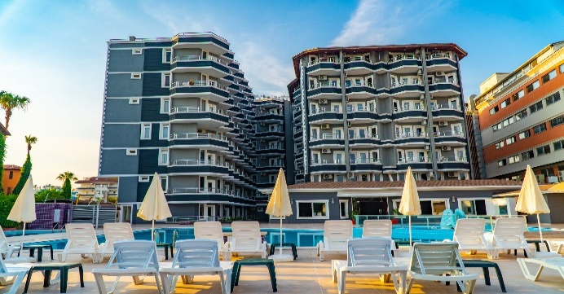

DISTANCES

* **Sea: 0**
* **Gazipaşa Airport: 55 Km**
* **Alanya City Center: 24 Km**
* **Antalya Airport: 136 Km**
* **General Transportation: Taksi / Dolmuş**
* **Doctor**
* **Sauna**
* **Turkish Bath**
* **Massage Room**
* **Market**
* **Nargile Cafe**
* **Baby Bed**
* **Wake up Service**

FOODS / DRINKS & ACTIVITIES TIME

* **Breakfast: 07:30 / 10:00**
* **Late Breakfast: 10:00 / 10:30**
* **Lunch: 12:30 / 14:30**
* **Dinner: 19:00 / 21:00**
* **Turkish Bath: 10:00 / 20:00 ( From 10:00 To 20:00 Free )**
* **Massage : 10:00 / 20:00 ( Paid )**
* **Lobby Bar: 10:00 / 24:00**
* **Pool Bar: 10:00 / 24:00**
* **Beach Bar: 10:00 / 18:00**
* **Slide Pool: 10:00 / 10:00 – 14:00 / 16:00**
* **Market: 10:00 / 23:00**
* **Pools: 07:00 / 18:00**
* **Snack Bar: 12:00 / 16:00**
* **Nigth Soup: 23:00 – 24:00**

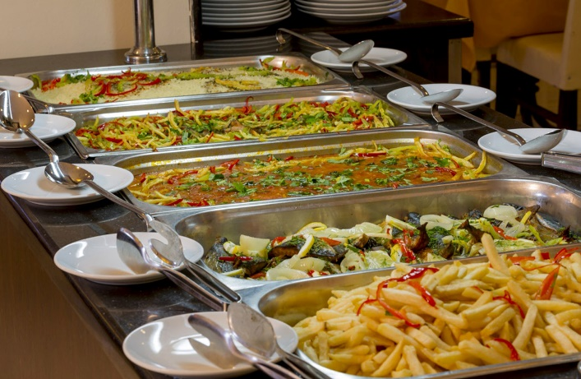 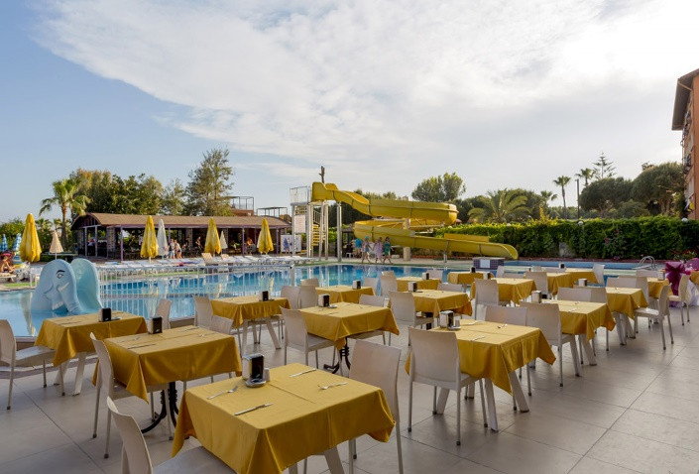

ROOMS

* **Total 157 Rooms / 470 People Capacity**
* **Standart Land View Room 26 M2 ( 2 Pax ) 1 French Bed or Twin bed**
* **Standart Sea View Room 26 M2 ( 2 Pax )1 French Bed or Twin bed**
* **Garden Bahçe Club Rooms 30 M2 ( 3 Pax ) 3 French Bed or 1French 1 Twin bed**
* **Family Room 40 M2 ( 4 Pax ) 1 French Bed And 2 Sng Bed**

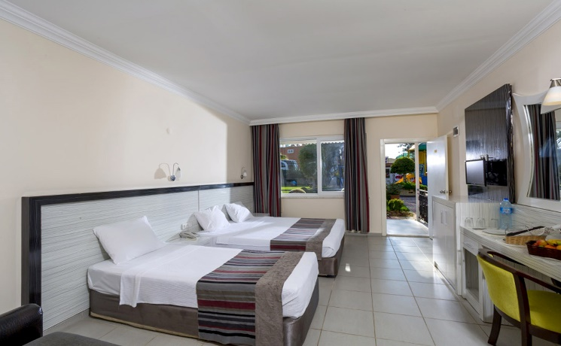 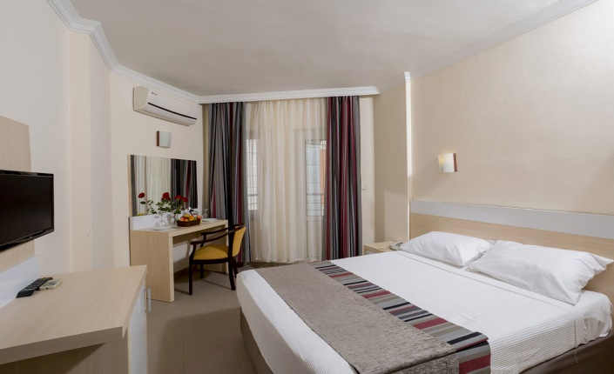

ROOM FEATURES

* **Garden & Seaview Rooms**
  + **Satellite Channels**
* **WI-FI ( Paid )**
  + **Hair Dryer**
  + **Electronic Safe ( Paid )**
  + **32” LCD TV**
  + **Door with Electronic Card System**
    - **Split Air Conditioner**
    - **Boucle Material**
    - **Balcony**
    - **Suitcases**
    - **Parquet or Ceramic Ground**

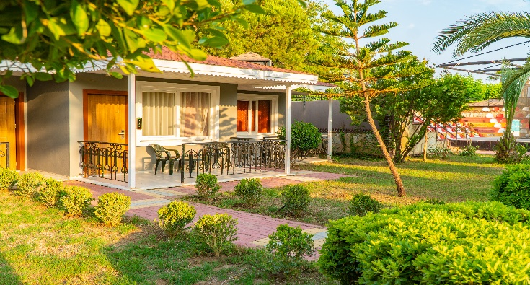

SPA CENTER

* **Sauna / Turkis Bath ( From 10:00 To 20:00 Free )**
  + **Skin Care ( Paid )**
* **Pouch Foam Massage ( Paid )**
  + **Massage / Care Package ( Paid )**

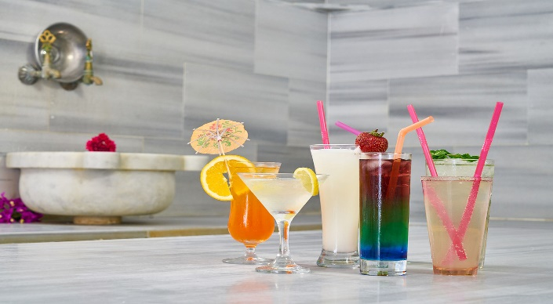 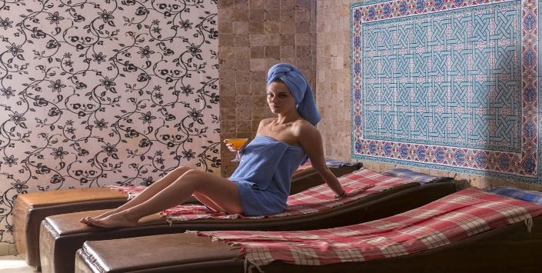

SWIMMING POOL & BEACH

* **Out Door Pool ( 15 M2 -150 Cm Depth )**
* **Out Door Kiddie Pool ( 20 M2 -50 Cm Depth )**
* **Slidepool ( 40 M2 -150 Cm Depth )**
* **Sanndy & Gravelly Beach**

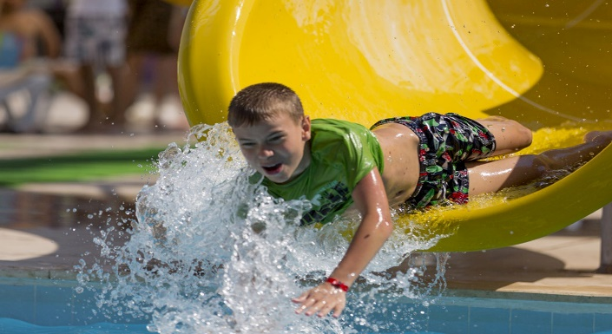 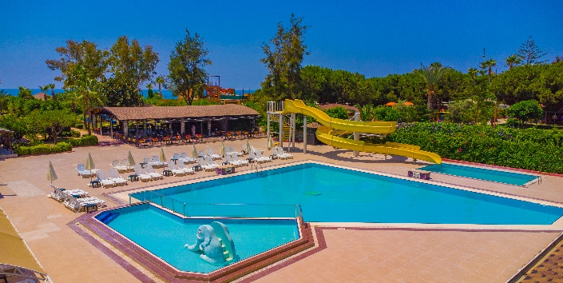

ENTERTAINTMENT & ACTIVITY

* + **Children’s Playground**
* **Mini Club**
* **Dart**
* **Beach Volleyball**
* **Animation Show**

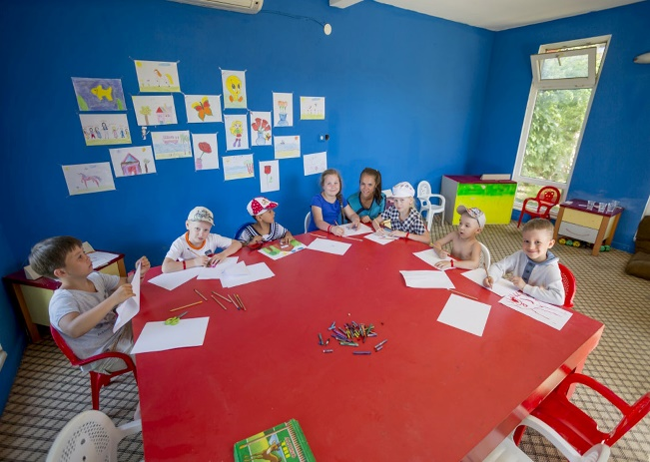 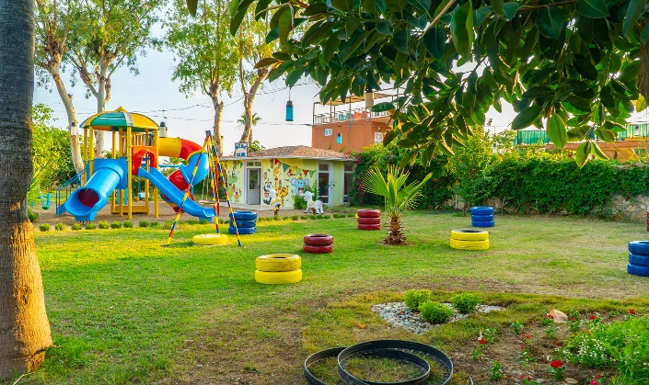

PAID SERVICES

* **Foreign Drinks / Bottle Drinks**
  + **Massage / Care Package**
* **Doctor**
* **Market**
* **Nargile Cafe**
* **Water Sports**

FREE SERVICES

* **Breakfast: ( Main Restaurant )**
* **Late Breakfast: ( Main Restaurant )**
* **Lunch: ( Main Restaurant )**
* **Dinner: ( Main Restaurant )**
* **Local Alcoholic Beverage or Soft Drinks: ( All Bars / Restaurant at Meal Times )**
* **Turkish Bath / Sauna**
* **Linen Change: Every 2 (two) days**
* **Towel Change: Everyday**
* **Sunbad & Umbrella ( Beach & Pools )**
* **Honeymoon Room**

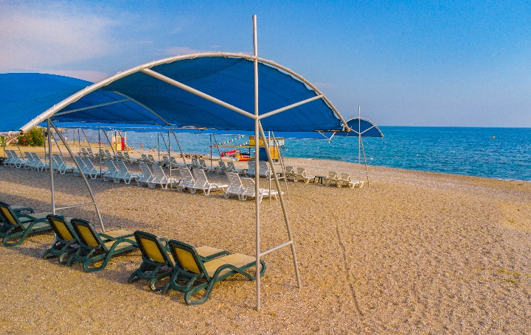 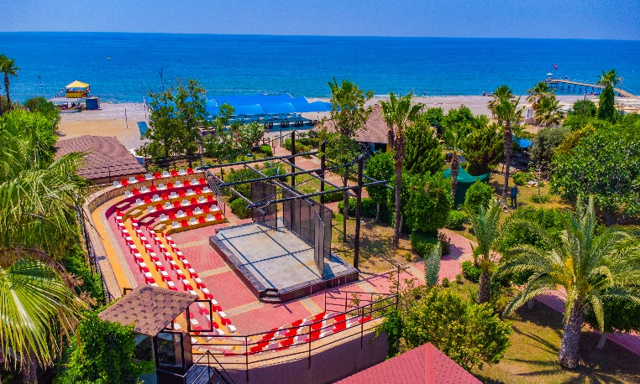

Konaklı Neighborhood Mustafa Kemal Boulevard No:4

Alanya / ANTALYA