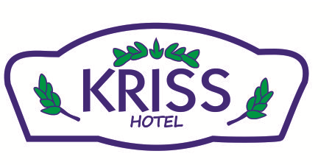

KRISS HOTEL 2023 FACT SHEET

HOTEL: KRISS HOTEL
CATEGORY: 3*
PENSION: All Inclusive
ADRESS : Yahşi Yalısı Ortakent/BODRUM
TELEPHONE: +90 252 3483450-3484037
FAX: +90 252 348 39 22
WEBSITE: www.bodrumkrissotel.com
E-MAIL : info@bodrumkrissotel.com
OPENING DATE: 2005
AREA: 4000m2
ROOMS: 45
BEDS: 100
FLOORS: 2 floors
PETS: not allowed
LANGUAGES: Turkish, English,Arabıc,
BEACH: 300 mt , public beach
TAXI: 24 hours
AIRPORT: 45 km
BODRUM CITY CENTER: 13 km
HOSPITAL: 6 km

45 Standard Rooms

- Daily room cleaning

Standard Rooms: 22-25m²
In all rooms there are TV, telephone , hairdryer ,ceramics floor, satellite tv, shower
and WC, split air-conditioning system,French balcony

Breakfast : 07:30-10:00
Lunch : 12:30-14:00
Dinner : 19:30-21:30
All meals are served at the main restaurant

All beverages are self service

Snacks : 17.00-18.00

Bar

Pool bar 10:00-23:00 ( For Drinks )

Local non-alcoholic and alcoholic beverages which are in our concept are included.
Special menu and imported drinks choices are charged

Food & Beverage

Included | Extra payment
Breakfast  Lunch  Coffee Break  Dinner  Local non-alcoholic and alcoholic beverages which are in our concept till 23:00 | Imported drinks  Energy drinks  Fresh juices  Turkish coffee  Bottled drinks

Sports & Entertainment

İncluded | Extra payment
Swimming pools
Darts
Table tennis
Children garden

