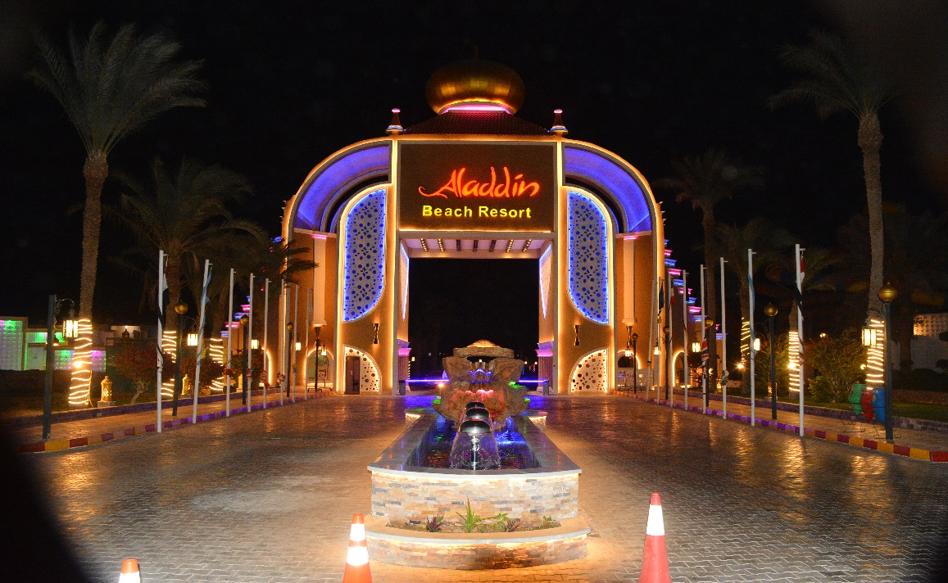

Hotel Fact Sheet

Aladdin Beach Resort is a hotel located in an area of 134,400 m² which puts you at the heart of Hurghada, conveniently close to everything the city has to offer. You are only a short drive 8km from the airport, and close enough to stroll around Hurghada and take in the inviting atmosphere, unique culture and fascinating sights on offer. The hotel boasts its own private beach, with stunning, serene views of the famous Red Sea, and there is a range of different activities available locally.
General
Address: | Aladdin Beach Resort  17km Village Road, Hurghada, Red Sea, Egypt
Category:  Phone:  Mob:  Fax:  General Manager:  Front office Manager  Guest relation:  Sales Department: | 4 stars  +20653460466  +201279034444  +20653460469  Mr. Adel Saad, E-mail: aladdin.gm@hwaidakhotels.com  Mr. Nail Nashaat, E-mail: aladdin.frontoffice@hwaidakhotels.com  aladdin.gr@hwaidakhotels.com  Mr. Hamada Abdel Dayem: asst.dosm@hwaidakhotels.com
Reservation: | aladdin.reservation@hwaidakhotels.com
Website: | www.hwaidakhotels.com  https://drive.google.com/drive/folders/1M5JqOARpmsYVRbeuX4vgEobs7WeaRkZV
Date of inauguration: | 1995
Last renovation: | 2021
Languages: | 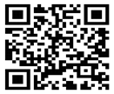  English, German, Russian, Multilingual staff at  the reception, guest relation desk and animation team.
Type of catering: | All inclusive

Rooms
Number of rooms: 489

Standard Room:

264 rooms with garden view, about 30-35 sq. m, Maximum 2 Adults +2 Children or 3 Adult +child occupancy. With: twin beds (120 cm wide), extra bed upon request, shower, WC, air condition, direct Telephone, sat. TV, minibar, hair dryer, safe box and terrace.

Superior Room:
150 rooms with garden view, about 33 sq. m, Maximum 2 Adults +1 Child or 3 Adult occupancy. With: King Size bed (180 cm wide), extra bed upon request, shower, WC, air condition, direct Telephone, sat. TV, minibar, hair dryer, safe box and terrace or balcony.

Pool View Room:
26 rooms with pool view, about 33 sq. m, Maximum 2 Adults +1 Child or 3 Adult occupancy. With: King Size bed (180 cm wide), extra bed upon request, shower, WC, air condition, direct Telephone, sat. TV, minibar, hair dryer, safe box and terrace or balcony.

Family Suite:
40 rooms (2 Bed Rooms), Rooms equipped just like superior room with connecting door between, one room with king size bed (180 cm wide) and the other with twin beds (120 cm wide), about 45 sq. m, maximum 4 adults or 2 adult + 2children occupancy. With: 1 bathroom, WC, air condition, telephone, sat. TV, minibar, hair dryer, safe box and terrace or balcony.
Family Room Connected:
9 rooms (2 Bed Rooms), Rooms equipped just like standard room with connecting door between, both rooms with twin beds (120 cm wide), about 65 sq. m, maximum 4 adults +2 children occupancy. With: 2 bathrooms, WC, air condition, telephone, sat. TV, minibar, hair dryer, safe box and terrace.
Disabled Room:

2 rooms on the ground floor especial designed to meet the requirements and comfort of disabled people about 33-35 sq. m, maximum 2 adults or 1 adult plus 1 child.

Room cleaning and sheet turn daily.
Wi-Fi available for free in the lobby and the rooms

Concept

Free Of Charge Services
Food and local alcoholic drinks, minibar (refilled daily with mineral water), safe, daily sport facilities & night shows, health clubs gymnastic equipments, mini club, parasols, matress and deckchairs by the pool and on the beach, beach towels, umbrella and A la carte restaurants (Italian, Mongolian, Sushi and Fish) Reservation with Guest Relation one day before.

Paid Services

Bottles and cans of beverages,fresh fruit juices,medical services, Fish ALa carte restaurant, health club, sauna, jacuzzi, massage, water sports, laundry, dry cleaning (ironing), beauty salon, telephone, fax,shops, lost and damage of guest room key and safe key.

Pools
Min-Max
First pool (heated) freshwater 150-120 cm
Second pool freshwater 160-110 cm
Third pool (heated) freshwater 220-150-100 cm
First kids pool(heated) freshwater 60 cm included In the size of Main Pool
Second kids pool freshwater 50 cm included in the size of Main Pool
Third kids pool(heated) freshwater 75-65 cm included in the size of Main Pool
*Pools close at sunset.

Beach
Sandy & Pebble Beach
Length of the beach : 150 m
Deckchairs, mattress, parasols, beach towel, umbrella
Aladdin's guest can use jasmine beach which is one of the best sany beaches In Hurghada.

Food and Beverages

1 main restaurant, open buffet (breakfast, Late breakfast, lunch, dinner, late dinner), 5 bars are at your service. 5 A la Carte Restaurants. Reservation one day before and dress code is required.
Aladdin's guest has the right to use the bars, swimming pool and beach of Alibaba.
Aladdin's guest has the right to eat In the main restaurant in Alibaba with reservation by guest relation.

Food Services
Hours Services Restaurants
07:00-10:00 Breakfast Main Restaurant
10:00-11:00 Late Breakfast Main Restaurant
12:30-16:00 Snack Service Beach Restaurant
14:00-15:00 Ice Cream Service Pool Bar
12:30-14:30 Lunch / open buffet Main Restaurant
16:00-17:00 Tea Time Lobby Bar
18:30-22:00 Dinner / open buffet Main Restaurant
22:30-00:00 Late Dinner Main Restaurant
18:30-20:30 Italian a la carte (with reservation by gueast relation)
18:30-20:30 Mongolian (with reservation by gueast relation)
18:30-20:30 Fish a la carte (with reservation by gueast relation)
18:30-20:30 Sushi (with reservation by gueast relation)
18:30-20:30 oriental (with reservation by gueast relation)

Bars
Hours Services Bars
10:00-18:00 alcoholic-soft drinks Pool Bar
10:00-18:00 alcoholic-soft drinks Beach Bar
18.00 - 00:30 alcoholic-soft drinks Terrace Bar
21:30 - 23:00 alcoholic-soft drinks Disco Bar
09:00-00:30 alcoholic-soft drinks Lobby Bar
Lobby bar from 00:30 till 9:00 with extra charge

*Opening and closing times of the restaurants and bars can be changed according to season and weather conditions.

Entertainments& Activities

Day Activities :

International multilingual animation team; competitions, games and beach activities.

Tennis court till sunset, table tennis (ping pong), beach volley, darts, aerobics, water gymnastics, water polo, boccia, fitness programs, dance lessons (latino, oriental), beach games and dances.

Special event: according to the weekly programme.

* All swimming pool and beach activities are subjected to weather conditions.

Night Activities:

Every evening mini disco.

Theater Shows: competitions, cabarets, dances, live music, DJ, and many other extravagant shows.

Night discotheque at the disco.

Aqua-park:
Daily enterance to aqua-park (free of charge).
working hours: from 10:00 till 13:00 and from 14:00 till 17:00

Mini Club: Here is a fun way to learn and enjoy for kids 04 – 12 age between 10:00 - 12:30 and 14:30-16:00 and mini disco from 19:30 - 20:00.

Children & Teenagers

A multitude of great recreational activities that include a children’s pool, a specially designed playground, and various shows like Miniland and Minimix Show, a mini disco.
Specially planned activity program for teenagers.

Water Sports (Extra) :Water sport center.

Land Sports: kids club & children’s playground, one beach volley, one dart, aerobic and dance floor.

Healthcare Center (extra) Open between 09:00 - 19:30 Turkish bath, steam rooms, jacuzzi, massage rooms.

Security
Fire Exits
Warning signs
Height of balcony is 110 cm
Signboards around the pool
Lifeguards at the pool and beach

Useful Information
- All swimming pool and beach activities are subject to weather conditions.
- Smoking is not allowed in closed areas.
- Alcoholic drinks are restricted to ages under 18.
- Schedules and venues for outdoor events are subject to weather conditions.
- Aladdin Beach Resort Managemnet reserves the right to make changes without prior announcement.
- The hotel management is fully authorized to make amendments and/or cancellations regarding any aspect of the services offered. If and when such changes are made, the now-irrelevant information in the catalogue will be construed as simultaneously reflecting the changes made.
- Aladdin's guest has the right to use the beach and pool in Alibaba and has free entrance to the Ali Baba disco.

